EXPORTED

Evaluation of Video Control Interface for ERCP at
Karolinska University Hospital
Group Members: Alvi Syahrina, 890303-2665
Doga Yuksel, 871007-T575
Riasat Islam, 910406-8532
Shaun Mulligan, 880119-T373
Svanlaug Ingólfsdóttir, 890817-5725

Abstract
The aim of this evaluation was to examine the video control interface used in ERCP surgeries at the Karolinska Hospital and look for ways to improve the usability of it. The evaluation was conducted by students from Kungliga Tekniska Högskolan. Several usability tests were conducted in a surgery room with participants that use the video control interface during operations. The main tasks of interest were arranging views on selected screens and initiating a video call. The testing procedure consisted of three phases: pre-test structured interview, user tasks and semi-structured post-test interview. From the usability evaluation it is evident that changes should be made to the video control interface to mitigate hesitation and confusion for users while interacting with the system. The following recommendations are suggested: reduce the number of buttons with similar names or functions, implement the video conference function as a subsystem, remove the changing screen or views scheme, implement a call status feedback system and moving the tabbed menu to the top left of the screen.

Introduction
The system being examined is the video control interface used in ERCP (Endoscopic Retrograde Cholangio-Pancreatography) surgeries at the Karolinska Hospital. ERCP surgery is used to examine and treat problems with the pancreatic and bile ducts. During the surgery, the doctor uses a flexible tube to access the duodenum through the mouth, and navigates inside the patient using the feedback from the x-ray and the endoscope [1].
ERCP surgery is dependent on a reliable stream of video, since the surgeon uses the output of x-ray and endoscope displayed on a screen. The video control system primarily allows the surgery team to choose what needs to be displayed on screens in the surgery room, based on the requirements of the operation. It can display feedback from additional instruments such as a microscope or a spyglass if needed [2]. The success rate of the ERCP operation is dependent on the experience of the surgeon, but the rate is greatly increased by an experienced advising doctor at a distance [3]. Addressing this problem, the video control interface is also used to send the chosen views to third parties by initiating a video call [2]. The video control interface can help ensure high-quality ERCP operations for patients living in rural areas and therefore, it is important that the interface is simple and easy to use [4].
The evaluation conducted mainly focuses on the video control interface from a usability perspective and tries to identify how it fulfills certain usability criterias. Several usability tests were conducted in the surgery room with participants that actually use the system during operations. The main tasks of interest were arranging the views on selected screens and initiating a video call.
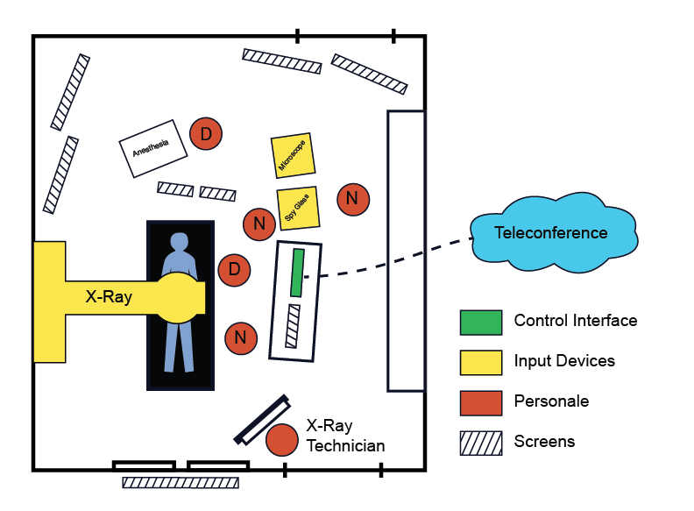
Figure 1: System Overview

Figure 1 shows the overview of the surgery room and the context of the control interface in Karolinska University Hospital. The control interface is located just behind the doctor conducting the surgery. It is generally controlled by the nurse standing next to the doctor. The figure shows several other instruments that can be connected to the control interface if required during the operation. The x-ray technician behind the protected glass manages the x-ray machine.

Method
The primary goal of the study was to improve the usability of the system, however it was not stated in which areas or ways the system needed to be improved. Therefore we assumed that the intended purpose of the study should be to reduce the complexity and increase the Memorability [5] of the system, so that system tasks can be performed quickly and correctly even in the high pressure situations generally found in surgery.
To evaluate the system, we decided on a qualitative methodology as we did not have much time to dive into the system software and design a robust quantitative methodology. We also were unable to evaluate the system during actual surgeries, due to principles of the hospital. It was concluded that any timing data captured in the simulated tests wouldn’t be affected by the stress of the surgery and in fact would not point out obvious bottlenecks in the system flow.
Our choice of qualitative analysis allowed us to understand what parts of the system the users had trouble with. It also allowed us to get an overall feeling of the user’s satisfaction with the system. The evaluation was structured as a series of interviews accompanied by a ‘thinking aloud test’ [SM2] on a set of predefined tasks for the user to perform.
The testing procedure consisted of three phases, namely the pre-test structured interview, the user tasks and the semi-structured post-test interview. During phase one, the pre-test structured interview, the participants were asked a number of questions, which were used to determine the users experience with the system and contextualize their test performance.
Phase two consisted of the predefined tasks. Here the user was asked to perform 9 tasks, common to the system usage during surgery. The participants were asked to verbalize their thought process while they completed these tasks so we could better understand the cognitive processes involved.
The third and final phase was a semi-structured debriefing interview. This interview was designed to collect the users’ opinions on the system and which parts of the system they found confusing or unuseful.
All of the testing was carried out on site at the Karolinska Hospital, in the ERCP surgery room. As mentioned earlier, the tests were not carried out during actual surgeries, but rather at a later stage with only simulated tasks. All of the interview questions and tasks for these three phases can be found in the appendix.
Data collection was done in three different ways. For each test a video camera was set up to record the screen input and the users interaction with the system. Additionally an audio recording device was used to capture the participant’s interview responses as well as their verbalized thoughts as they performed the system tasks. Finally, two members of the study team took on the role of observers and documented each test with handwritten notes.
The evaluation participants selection process was primarily based on which Doctors or Nurses were available on the given test days. According to our contact and supervisor, Rósa Guðjónsdóttir from the Karolinska Innovation Center, there are 13 nurses and 5 doctors that participate in surgeries using the ERCP video control system. However, not all of them are available every day and several of them never interact with the ECRP video control interface during the surgery.
During our study, the ERCP surgery team were kind enough to designate us four days to conduct our study. Each day we would attempt to evaluate participants on the system after the days surgeries had finished. However, many of the people in our participant pool, were very busy and stressed individuals, so they were unwilling to participate in our study. We didn’t have a chance to conduct any interviews on one of the designated days due to an ongoing surgery.
Finally after four days of testing we were able to gather data from three nurses and two doctors. However, the second doctor chose to opt out of the study as he had another surgery to attend to. So only a very basic interview was conducted with this subject.

Results
In this project, we evaluated performances of five participants to understand the usability of the video-control interface. We conducted a pretest interviews to learn about the different backgrounds of the participants and their familiarity with the interface . The pre-test interview findings are summarized as follows in the table below.

Table 1: Participants Details
Occupation | Assistant Nurse | Radiology Nurse | Head Nurse | Doctor 1 | Doctor 2
Years in the profession | 3yrs and 2 months | 2yrs | 20 years | Many years | many years
Familiarity with the system | 1.5 years | 1.5 years | None | 1.5 years | 1.5 years
Purpose of use | Operation | Operation | None | Operation/Examination | Operation/Examination
Frequency of use | 2-3 times per month | 3-4 times everyday | None | Mostly in the beginning of the operation | Expert, doesn’t require help

All the participants are trained to use the system and all of them have used the system for the same length of time. However, depending on their role in the operations, not all participants have interacted directly with the system, thus the familiarity of the system cannot be determined by only looking at how long they have used the system. Their role in the operation is more important and should be taken into consideration.
The participants were asked to perform a number of tasks as show in the appendix. The tasks were video taped and later their transcripts were prepared. After analyzing the evaluation tasks, following critical incidences were observed and their severities ranked.

Table 2: Problems
Serial No. | Interface Screen | Reference | Critical Incidence | Reason | Scope | Severity
1 | 4 buttons | Assistant Nurse, Radiology Nurse | Pressed “videoconference” button on the bottom right first by mistake | There are many buttons for “videoconference” | Making a call | High
2 | Presentation Tab | Head Nurse | Not a clue where “presentation” tab is | Cannot recognize the appropriate button | Changing Screen | Low
3 | Changing View | Head Nurse | Did not turn off Monitor 1, does not change 3-split | Unaware | Changing screen | Low

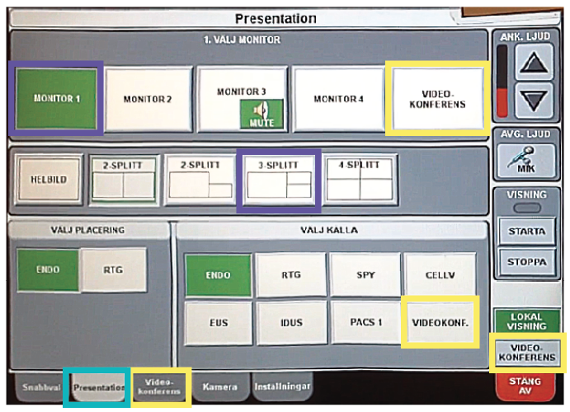
Figure 2: Screen Selection Screen

Table 2: Problems (continued)
Serial No. | Interface Screen | Reference | Critical Incidence | Reason | Scope | Severity
4 | Ending the Call | Assistant Nurse, Radiology Nurse, Head Nurse | Tried other button first before finding the right one (mistake) or needed help | Unclear button labeling, ambiguous placement | Ending the call | Medium
6 | Turns Off System Mistakenly | Radiology Nurse | Turns off the system when did a wrong call | Does not know how to end the call, does not receive feedback (that there is a call going on) | Make a call | High
7 | Ring Button | Radiology Nurse | Cannot find ring button | All buttons use words instead of metaphors and symbols | Make a call | High
5 | Figure: Quick Dial (Seen on Next Page) | Radiology Nurse | Pressed the contact from the quick dial (mistake)` | Used to pressing quick dial | Make a call | Medium

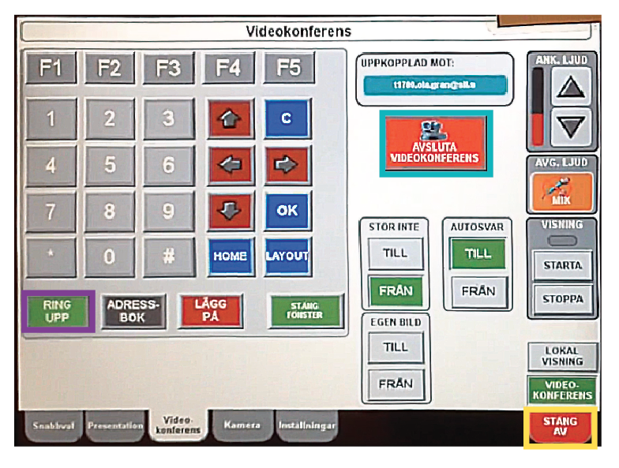
Figure 3: Manual Call Screen

Considering the background of the participants and their performance in the evaluation tasks, it is clear that although the participants have received training to use the system, they still face some difficulties when interacting with system. However, not all the participants use the system regularly. Those who use the system frequently were able to perform some of the tasks very well. Still they found certain tasks difficult to perform. Such as critical incidence number 1 and 4. Both the problems are related to unclear labelling of the interface. In order to understand the situation even better it should be noted that the system is generally operated in a stressful scenario while the operation is going on. As a result, the users can not make mistakes or be hesitant or confused when using the system. Thus, the interface needs to be redesigned with clear labelling and use of metaphors and symbols employed. The system should also incorporate visual feedback in certain tasks. The recommendations are outlined in the next section.

Moreover, it is to be noted that the learnability and memorability of the system is low. That is evident from the performance of the evaluation tasks from the users who do not use the system frequently. They have to recall from memory rather than recognize the interaction mechanism, which is one of the primary drawbacks of the current interface.

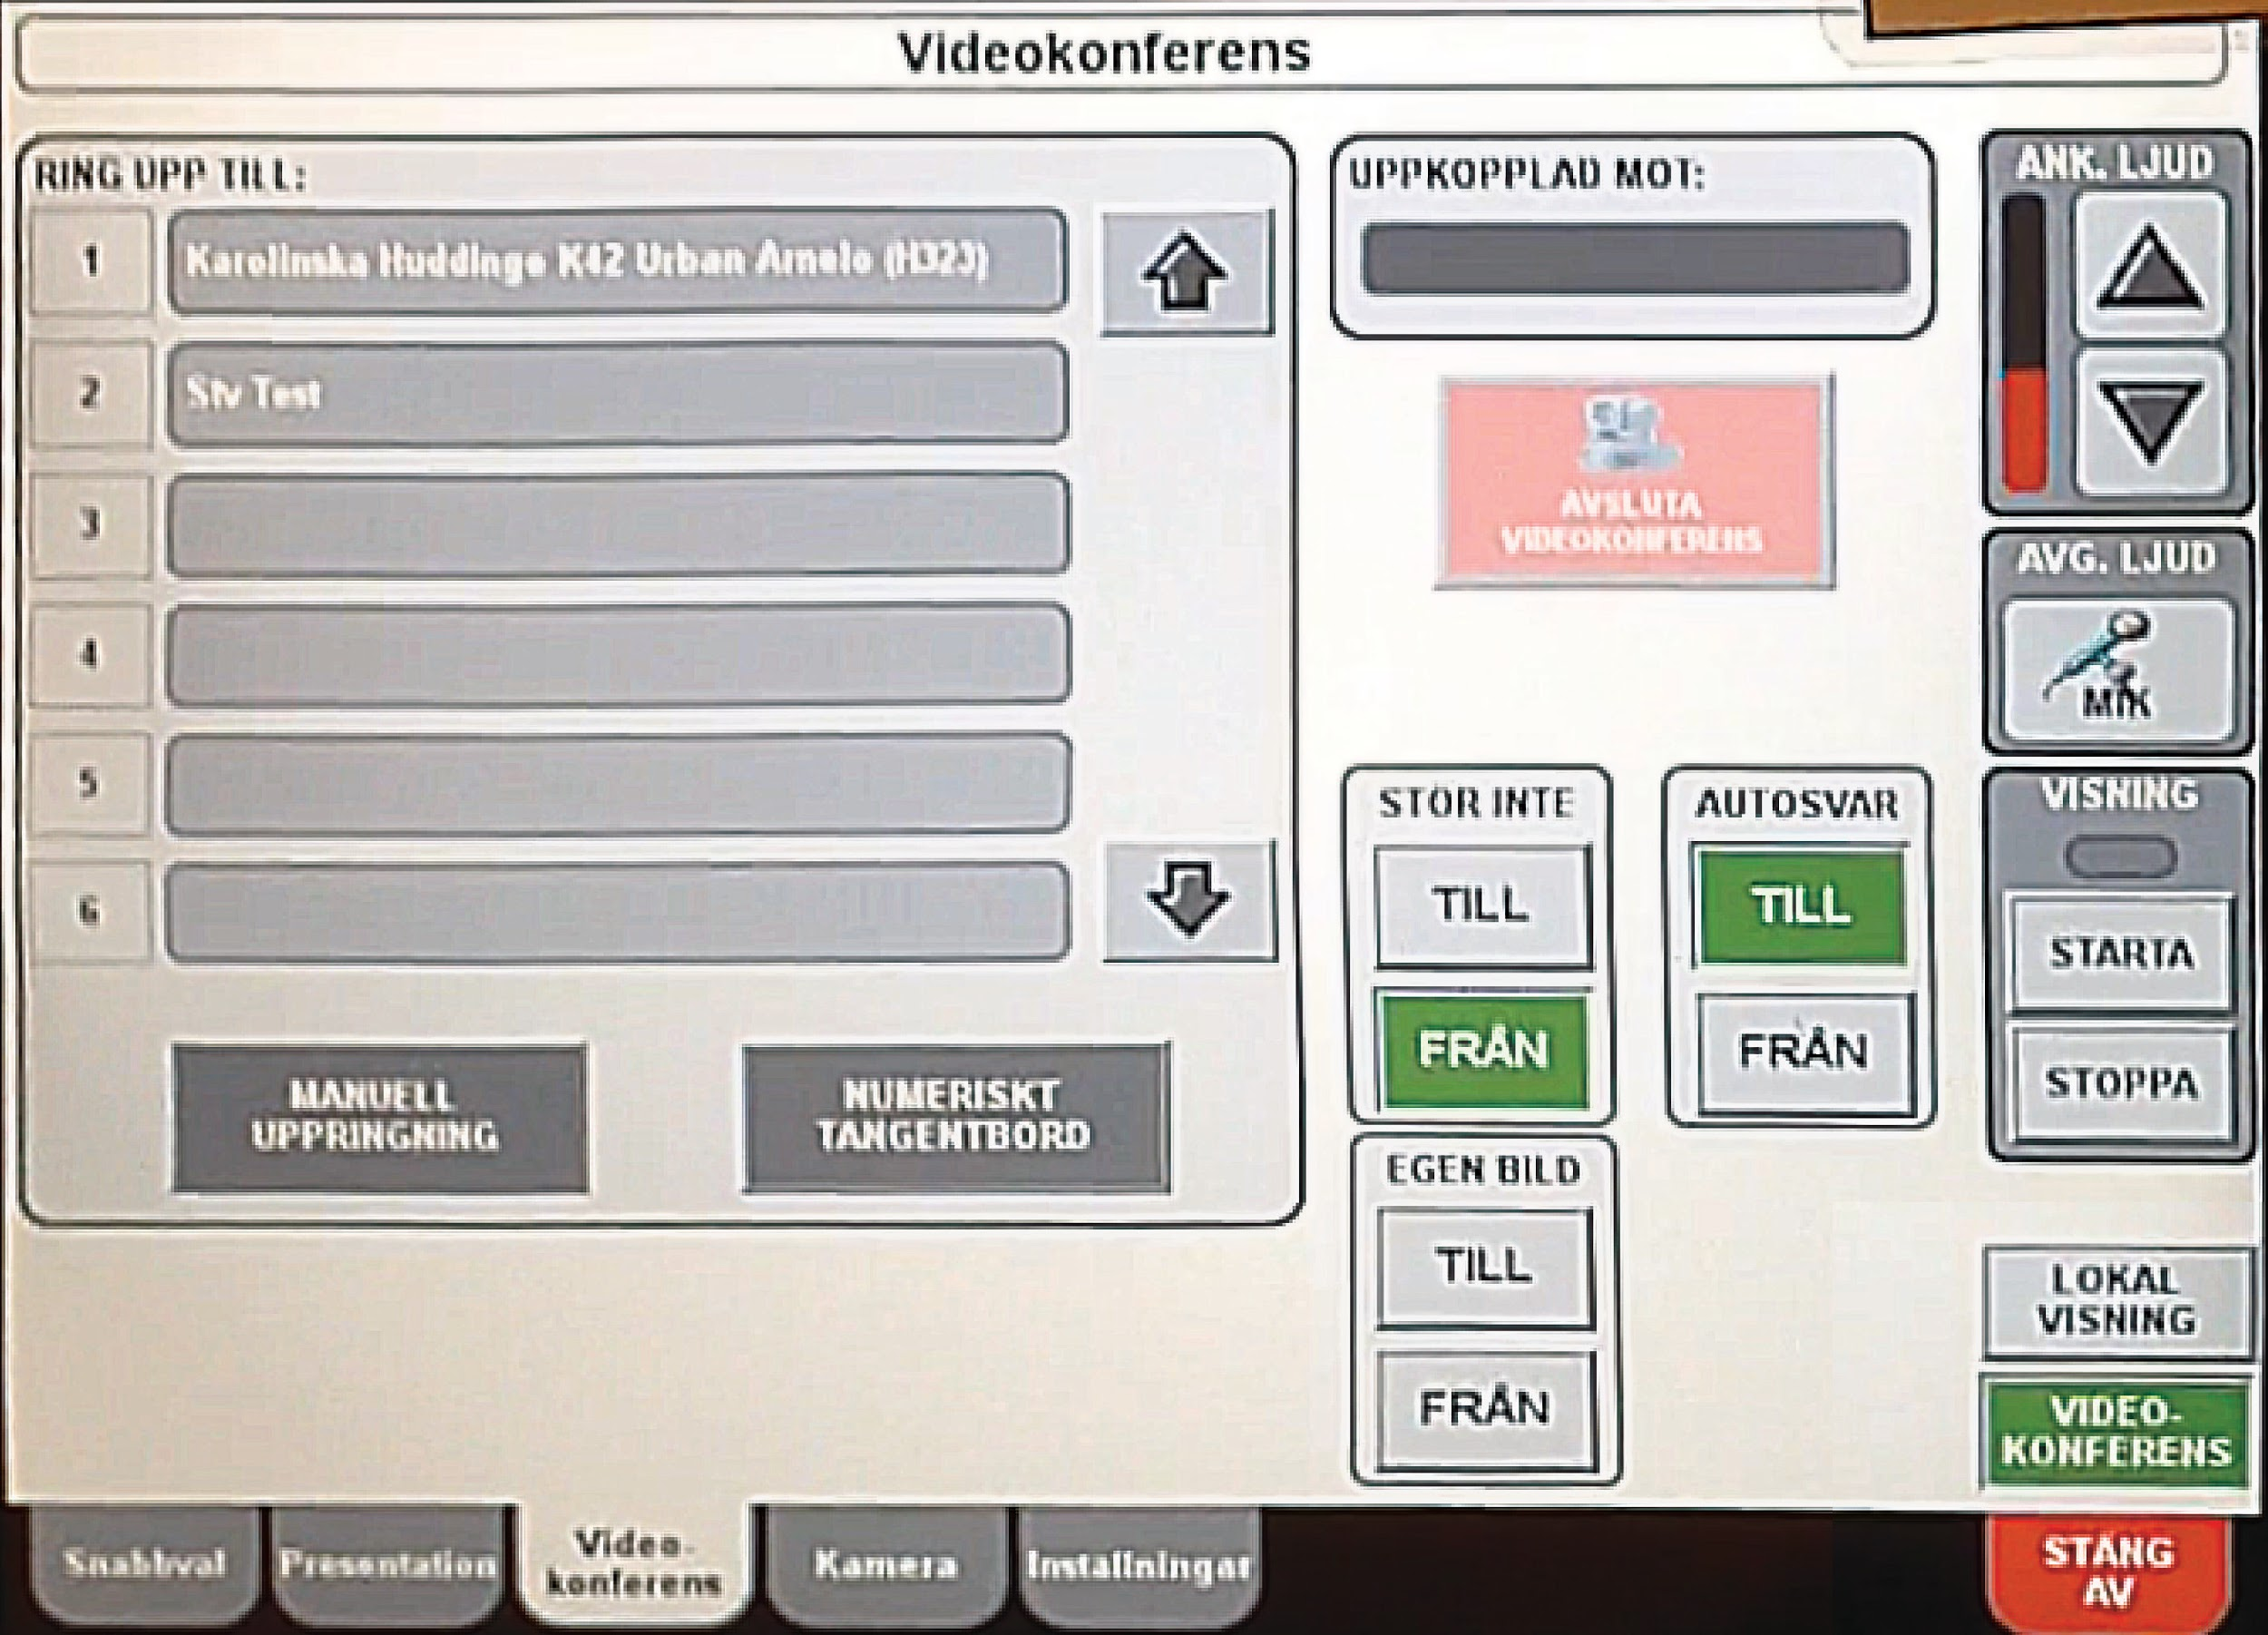
Figure 4: Quick Dial

Post test interview
After the users done the tasks, they were asked questions to reflect on what they feel about the systems. Their responses can be summarized into three major issues about the system.

Assistant Nurse: “It is easier if you do it several times at a week. But when it is maybe two weeks since I last used it I have to think.”
Doctor: “They have taken teaching lessons more than once you know two or three times so that everyone should be how to do this and still they can’t do it.”

Firstly, participants felt that the functions in the system were not that recognisable. From the assistant nurse’s quote we can infer that users should always remember the location and function of the buttons. The doctor who was actively involved in the development of the system also support this view. He indicates that this system require an effort to memorize and it is difficult to memorize.

A Doctor said, “No, I can’t think. Ok, let’s try. I don’t really know. I hate it as I told you when you analyze that there are 4 video conference buttons in the same screen. 4 buttons with the same name”

Assistant Nurse said, “It says the same the [sic] on several buttons, they say the same thing, and that makes me really confused sometimes. Yes, stäng av (shut off) and från (from). two, three things say the same thing to me.”

Radiology Nurse: “There are 3 video conference buttons on the screen”

The interface consists of buttons and to distinguish the functions between buttons, simple words are used. It turns out that there are a few buttons that have the same name. At certain points in the interface, users say they see four buttons having the same name. Although the buttons may have slight differences in function, having the same name will confuse the users.

Assistant Nurse: “I mean there many of these. I mean.. possibilities to choose screens. I mean.. you mostly be are just fiddling with two three of those.”
Q: “Is there any function in the system that you do not use?”
Doctor: “Probably. But, not that I can say. But I think it is so.”

The system’s function is not complex but the developer of the interface provided too many alternatives to interact with it. For example, in choosing different cameras to put up on the screens, users can choose between pre-set templates or manually choose them. The assistant nurse’s quote shows that not all the templates are used. The doctor’s quote shows that there are unused buttons in the interface.

Recommendations
In consideration of the critical incidences during the evaluation tasks and the post-test interview feedback from the participants, the following recommendations are suggested.
- In light of critical incidence 1, there are often states in the system interface where there are multiple buttons with the same name, for instance, “video conference” buttons. Our recommendation is to reduce the number of buttons with similar names or functions as this tends to lead to user confusion. There should be one concrete way of accessing the video conferencing functionality.
- Following on from the above suggestion and in the light of the scope of the critical incidences number 1, 5, 6 and 7, it is evident that the users generally find it difficult to interact with the system due to steps involved to make a call. As a result, it would be appropriate to implement the video conference system as a subsystem. As the system currently stands, it has two options to run the system either in local viewing or in conference mode. However, the majority or core of the system runs in exactly the same regardless of the mode selected. We would suggest removing this mode selection screen and having the system always start in local viewing mode, but have a very visible way of starting a video conference. This subsystem for the video conference could initiate some kind of quick setup wizard to effectively set up the screen views to be transmitted as well as which number or shortlist person to call.
- Considering the scope of critical incidences 2 and 3 it is evident that the changing screen or views scheme should be made easier. Also from the interviews we found that none of the users use the templates functionality. They are more comfortable with manually setting the screen setup. Our recommendation is to remove this function altogether because it adds unnecessary bloat to the interface and increases complexity.
- Considering critical incidence 4 and 6, it was noticed that very few people were able to end the current video conference call when asked to do so and additionally were unable to determine if they had in fact ended the call. We feel that the system gives very poor visual feedback with regards to the active call status and recommend that some kind of call status feedback system be implemented. It should be clear to the user that a call is currently active, and they should be able to easily terminate the call.
- Considering critical incidence 2 and in general, it was found that the users struggled to notice or find the tabbed menu at the bottom. This may be due to the fact that these buttons do not look very “clickable” or possibly because the tabs positioned at the bottom of the screen is unconventional. We recommend moving the tabs to the top left of the screen as this is more conventional in UI design. It may also be beneficial to increase the size and visibility of these tabs.

Discussion
In order to improve the team’s session-moderation skills, the team evaluated how our evaluation went. The team both watched recordings of the evaluations, as it is an ideal medium for reviewing the team’s performance [7], and had a reflective session where the team discussed the evaluations, what went well and what could be improved.

There were several things in the evaluation that the team felt went extremely well. Firstly, the team managed to get a good coverage of different user groups. Secondly, it is an advantage to evaluate the system on the spot, i.e. where it is actually used. Therefore, the location of the evaluation had no effect, as users were familiar with using the system there. Furthermore, the team got the opportunity to observe operations where the system was being used and therefore, got a live experience. Although it was not a part of our evaluation plan it was beneficial for the team as it enabled us to observe the stressful atmosphere in the operation room.

However, as it was the team’s first evaluation experience, there were some drawbacks that we intend to learn from and improve in the future. First of all, while doing the evaluations the team got to know the system more and realized that some questions lacked insight. The questions asked the same thing or were not properly formulated due to the team’s lack of knowledge of the system or ERCP. At first the team was too rigid with the test plan and did not deviate from the test plan, but after two evaluations the team started to sense that the test design was not achieving its objectives and made appropriate changes so that the participant’s time and efforts were not wasted [7].

Secondly, the limited number of participants was a drawback. Although the team managed to get all the user groups however, more participants from each user group would have resulted in a better overall evaluation.

Thirdly, the team believes one of the major drawbacks of the overall evaluation process was that the participants were either tired due to the stressful day’s work or they were distracted due to the busy environment of the operating room. Some of the participants were exhausted after a tiring work day and were hurrying through the evaluation process since they just wanted to get it over with and go home and rest. On the other hand, when the evaluation team tried to perform their evaluation during working hours, the participants seemed to be distracted due to their busy schedule. This resulted in leading rather than enabling [7], i.e. as there was limited time to do the evaluations it was not possible to give the participants time to work through the hindrances. As the participant’s behavior at this point, during hindrances, can be more revealing than at any other time the team missed a possible opportunity understand how the participant learns to use the product [7].

Lastly, another major drawback was that the system was in Swedish, including the documentation, and some of the participants were not confident in their English ability and had trouble understanding some of the interview questions. All the participants were proficient in Swedish whereas none of the members in the evaluation team was proficient in Swedish. Thus, there was a clear language barrier presented itself during the whole evaluation process.

The team got the opportunity to observe a doctor receive a call, from the operating room, in his office and afterwards speak to him about his experience and opinions. He conveyed frustration that he could not make changes, e.g. make views larger, switch templates, and therefore, always needed to ask people in the operating room to do it. Thus, future work could be to evaluate that system too and find a solution that would improve the usability of both systems.

Conclusions
In conclusion, it is evident from the usability evaluation that considering the stressful context of the operating room the user interface for the ERCP system should incorporate certain changes that would mitigate hesitation and confusion for the users while interacting with the system. The users should be able to recognize the interface readily rather than perpetually recalling the interaction mechanism. Employing metaphors, symbols and better visual feedback should help the users to perform their tasks more effectively and increase the memorability of the system.
Another important finding in this particular usability evaluation includes that in reality the ERCP system is used for video conferencing sometimes and for each operation it is used for local image projection within the operating room. Thus, the evaluation team strongly suggests to make the video conferencing system as a sub-system, which can be used only when required including the call feature. As a result, much of the difficulties on the user’s part can be mitigated.

References
[1] “ERCP (Endoscopic Retrograde Cholangio-Pancreatography) Patient Information from SAGES.” [Online]. Available at:http://www.sages.org/publications/patient-information/patient-information-for-ercp-endoscopic-retrograde-cholangio-pancreatography-from-sages/. [Accessed: 17-Dec-2013].
[2] “Bruksanvisning för bildöverföringssystem med RTG-container.” STV.
[3] J. Baillie, “The Use of Telemedicine for Performing ERCP,” Gastroenterology & Hepatology, vol. 9, no. 9, pp. 597–599, Sep. 2013.
[4] H. I. Påhlsson, K. Groth, J. Permert, F. Swahn, M. Löhr, L. Enochsson, L. Lundell, U. Arnelo, “Telemedicine: an important aid to perform high-quality endoscopic retrograde cholangio- pancreatography in low-volume centers”, Karolinska University Hospital, 2012
[5] Jakob Nielsen, “Usability 101: Introduction to Usability”, Available at: http://www.nngroup.com/articles/usability-101-introduction-to-usability/, [Accessed: 17-Dec-2013].
[6] Nørgaard, Mie, and Kasper Hornbæk. "What do usability evaluators do in practice?: an explorative study of think-aloud testing." Proceedings of the 6th conference on Designing Interactive systems. ACM, 2006.

[7] Dana Chisnell, Jeff Rubin, “Handbook of Usability Testing”, Wiley Publishing, Inc., 2008.

Appendices
Appendix A: Evaluation Script

Introduction and Explanation of study

“Thank you for agreeing to take part in our research study. My name is Shaun, and this is Alvi, Doga, Riasat and Svana. Here is a consent form, can you sign it / May I have your signed consent form, please? Thanks.

“During the rest of the session, I’ll be working from a script to ensure that my instructions to everyone who participates in the study are the same.

“We are here to learn about ERCP video communication system .

“During the session, I will ask you to use the ERCP system to do a variety of things and will observe you while you do them. As you do these things, please try to do whatever you would normally do.

“Please try to think out loud while you’re working. Just tell me whatever is going through your mind. Please know that we’re not testing you, and there is no such thing as a wrong answer. Your doing this helps us understand what works or doesn’t work in the system.

“By the way, I’m an independent researcher who had nothing to do with the design of this system. So please be honest in your feedback—I need to know exactly what you think, not what you think I want to hear. The rest of the team is here to record and take notes.

“The whole session will take about 20 minutes.

“Do you have any questions before we begin? [Answer any questions.]”

Pre-test Interview

Occupation: Doctor / Radiology nurse(Röntgensköterska) / Assistant nurse(Undersköterska) / nurse(Sjuksköterska)
How long have you been in this field?
How long have you been working with this setup?
What are the various cases you use this system, such as operation, examination, practice...
How often do you use the system during each of the cases?
What are the inputs you use the most? What templates do you use the most?
How long does each interaction with the system take on average?
How often do you change a view? Do you ever change the view on the camera?

Evaluation tasks

- Start the system
- Set a view (rtg - endo)
- Make a call (1012221)
- For the conference view, add a spy glass screen to make it 3 images.
- Mute the call and unmute.
- Stop sending data to the conference screen.
- End the call.
- For the second screen in the operation room, change the view.
- Turn off the system.

Post-test Interview
Do you feel that the system is usable?
What things annoy you about the system?
What are the difficulties did you find while using the system?
What do you think are the strengths of the system?
In your opinion how could the system be improved?
Is there any function in the system that you do not use? Do you think it should be removed?
Is there anything that we have not asked, that are of importance?
For Doctor: How often do you make the changes on the system by yourself.
For Nurses: How do get instructions interacting with the system?
Do you ever need to make a call due to an emergency to get an opinion?
Do you ever call someone that you don’t have on the short list.

Thank you…

Appendix B: Consent Form
Nondisclosure and Recording Consent
KTH Royal Institute of Technology

Title of Project: Video communication solutions for consultation at a distance

Principal Investigator: Shaun Mulligan, email: shaunmu@kth.se.

Advisors: Git Eliasson, email: git.eliasson@karolinska.se, and Rosa Gudjonsdottir, email: rosa@pinkpuffin.com

Other Investigators: Alvi Syahrina, email: syahrina@kth.se
Doga Yuksel, email: doga@kth.se
Riasat Islam, email: riasati@kth.se
Svanlaug Ingólfsdóttir, email: svanlaug@kth.se

1. Purpose of the Study:
The purpose of this research is to assess the usability of the video communication systems control interface used in Gastro Centrum surgery (ERCP) at the Karolinska Hospital.
2. Procedures to be followed:
You will be asked to complete a brief questionnaire, after that you will be asked to perform three predefined simulated tasks on the control interface mentioned above. During these tasks we will require you to verbalize your thought process as you navigate the system. At the end of the evaluation, some simple follow up questions will be asked by the evaluator.
3. Duration/Time:
The entire evaluation is not expected to take longer than one 30 minute session.
4. Statement of Confidentiality: Your participation in this research is confidential. In the event of a publication or presentation resulting from the research, no personally identifiable information will be shared.
5. Right to Ask Questions: At anytime during the study, please do not hesitate to ask questions or voice any concerns. Please contact Shaun Mulligan, by phone: 072 032 5827 or by email: shaunmu@kth.se, with questions or concerns about this study.
6. Voluntary Participation: Your decision to be in this research is voluntary. You can stop at any time. You do not have to answer any questions you do not want to answer. Photographs and recordings will be made of the session.

If you agree to take part in this research study and the information outlined above, please sign your name and indicate the date below.

___________________________________________ _____________________
Participant Signature Date

___________________________________________ _____________________
Person Obtaining Consent Date

Appendix C: Transcripts

Transcript - Assistant Nurse

Pre-test Interview

Before the interview she says: “Now I think it is the best we have (talking about the system), we have a more complicated before, much more complicated. We never learned how to use that system. Now I can, if I stay here for a while and think I can use the system.”

Occupation: Assistant nurse(Undersköterska)

How long have you been in this field?
3 years and 2 months.
How long have you been working with this setup?
1,5 years (maybe 2), I don’t remember when they changed, we had it once before, and we participated in the development.
What are the various cases you use this system, such as operation, examination, practice…?
Operation and when we have a doctor here, not working so long, and he needs help from the experienced doctor, that has worked very long, he is the master, he is the best. We can call him and he can help on a screen and he can look at what we do in the x-ray and endoscopic view and he can speak and stay in his room and help.
How often do you use the system during each of the cases?
2-3 times in a month.
What are the inputs you use the most? What templates do you use the most?
Always xray and endo.
How long does each interaction with the system take on average?
Not long, 30-50 seconds.
How often do you change a view? Do you ever change the view on the camera?
We change. It depends on what they are doing, on average once.

Evaluation tasks
Start the system.
(She started the system immediately.)
Set a view (rtg - endo).
(Did it easily.)
Make a call (1012221).
“How do I do this, maybe if I press video-conference here, we can maybe make it, this is how it is, I don’t do it so often and I have to think and stay here and it is middle of operation and it can be very difficult. And often there are two nurses and one assists the doctor and one is round and the one who is round does this so we can focus.” (In the end she finds it and makes the call.)
For the conference view, add a spy glass screen to make it 3 images.
(Does it easily.)
Mute the call and unmute.
(Does it easily.)
Stop sending data to the conference screen.
”I can’t, maybe I stop there, yes it is there”. (She does it pretty quickly.)
End the call.
(She looks for it for a while, and is thinking for a while) ”How do I do it, don’t know where I do it, should I turn off the system?” (In the end she finds it.)
For the second screen in the operation room, change the view.
(Does it easily.)
Turn off the system.
(Does it easily.)

Post-test Interview

Do you feel that the system is usable?
Not easy to use, but you can. It is easier if you do it several times at a week. But when it is maybe two weeks since I last used it, I have to think.
What things annoy you about the system?
I don’t know, maybe I want to have some instructions, very easy and points that say 1,2,3, easy when I lose my mind. It is a stressful situation and then the mind is often really stressed.
What do you think are the strengths of the system?
That we can call someone when we need help and that we can use that we do here for in Norrland in Sweden or Gotland and even to Europe.
In your opinion how could the system be improved?
It says the same the on several buttons, they say the same thing, and that makes me really confused sometimes.
Do you have an example?
Yes, stäng av (shut off) and frän. two, three things say the same thing to me
Is there any function in the system that you do not use?
Probably. But, not that I can say. But I think it is so.
Do you think it should be removed?
No, I can’t answer that. Maybe the doctor use something that what we don’t know what is and he needs to have it.
Is there anything that we have not asked, that are of importance?
No, maybe you can ask the experienced doctor about it, he is the expert.
Do you ever call someone that you don’t have on the short list?
No, and when we do the doctor has the number.
She says: “And then we often have packs, we can take from Journalen (the directory of patients, and see the photos from the last time the patient was here, maybe the x-ray, and we can put it up on the screen. And we can compare.”

Transcript - Radiology Nurse

Pre-Task Interview

Occupation: Radiologic technologist.
How long have you been in this field?
Hmm. 2 years about.
How long have you been working with this setup?
The Whole, almost the whole time, hmm, we have had this one, I think one and a
half year.
Okay, What are the various cases you use this system, such as operation, examination?
It’s when we operate, when we are doing the treatment. We always use this one.
How often do you use the system you think, well?
Every day.
But, but for each operation, how often do you use it?
We have 4 patients every day about, so its for 4 patients.
Okay, But when you have the patients inside?
I am touching it? It is on, we touch before, we started the patients, then its on, because we see the pictures. We have the endo pictures and the x-ray. And sometimes we, when we want to change to another picture because we have a lot of things which is going through this, so then we are changing this parameters.
What are the inputs you use the most display on the screen?
Its x-ray and endoscopy. Spy glass, now we have a new one, selvisio, but the most common is x-ray and
the endoscopic pictures. Several Systems. It’s what we are using everyday.
Okay, How long does each interaction with the system take? On average, how long are you to do this?
It is not long, it’s very fast
Very Fast, maybe a few seconds?
Yeah. If you know the systems.
How often do you change the view?
Its everyday also.
Yea but, if you have the doctor at side here, are you changing the view to spy glass or something?
Yes it happens, it depends on what the investigation is.
But on average, once or twice?
About five times maybe.
Okay, great now I’m gonna ask you to do some tasks…

Evaluation tasks

Start the system.
Yes, okay, that takes 20 seconds. (Starts the system in local settings)
Set all the views to (rtg - endo).
Endoscope, yes okay. (Presses local visning.) (Takes some time to find presentation screen.) (Doesn’t set all the screens, sets just the first one in the presentation tab.)
Make a call (1012221).
Okay now I have to remember. (Right side bar draws her attention.) (Presses the quick dial, starts calling, shuts down the system.)
Now we are switching off, I am not so good, I am not doing the whole. (Starts again.)
She can’t remember, Interviewer finally shows the way.
Mute the call and unmute.
Mutes the call.
Add a spy glass screen to make it 3 images.
(Adds it the monitor 3, which is outside the room)
Stop sending data to the conference screen.
(Goes to right bar, and stops it.)
End the call.
(Quickly goes to the video-conference tab, takes some time to find the stop button.)
Great!! For the second screen in the operation room, change the view to endo.
(Goes to presentation quickly, chooses M2, disables M3.) (accidentally mutes it.)
Turn off the system.
(Turns of the system easily.)
Post-test Interview

Do you feel that the system is usable?
It’s usable, yes, but it can also be difficult, because I know from sure for me that I can’t handle for 100 percent, it’s just the things I used to do, not more.
Okay, What things annoy you about the system?
Thinks, hmm- It’s annoying, like now, when we try to call then I want to make a picture, choose the picture and I am not sure how to handle it.
Pretty complicated?
Yea, it is complicated, it’s complicated.
What do you think are the strengths of the system?
I think, when you, it’s a good idea, this one to have. It’s a small thing here and you can choose and it’s connected to the different tv, you can choose between this what you want to see.
In your opinion how could it be improved?
I don’t know, maybe some easier to work with.
Fewer buttons?
Yes, simple.
Is there any function in the system that you do not use? Do you think it should be removed?
I think we use many of them, yes and it’s common new thing gonna be connected to this one.
Do you ever need to make a call due to an emergency to get an opinion?
No.
Do you ever call someone that you don’t have on the short list?
They just call one person.

Transcript - Head Nurse

Pre-test Interview

Before the interview she says: “Now I think it is the best we have (talking about the system), we have a more complicated before, much more complicated. We never learned how to use that system. Now I can, if I stay here for a while and think I can use the system.”

Occupation: Nurse(Sjuksköterska)

How long have you been in this field?
20 years maybe.
How long have you been working with this setup?
Not so much, nearly nothing - (doesn’t use the system a lot)
Have you used it?
Today
What are the inputs you use the most? What templates do you use the most?
X-ray I think.

Evaluation tasks

Start the system.
(Did it quickly.)
Set a view (rtg - endo).
”Oh, visning? maybe, I’m not sure” (She finishes the task with the help of the interviewer.)
Make a call (1012221).
Off... Maybe this?, make a call! There? (She does it pretty quickly.)
For the conference view, add a spy glass screen to make it 3 images.
Presentation, 3, spy... (Does it quickly.)
Mute the call and unmute.
Mute? here? (She does it quickly.)
Stop sending data to the conference screen.
Oh my god, stop maybe? (Does it quickly.)
End the call.
Start, nej. (She looks for it for a while) Call again? No I don’t know, aahhh! slutta” (She does it.)
For the second screen in the operation room, change the view.
(Did it quickly.)
Turn off the system.
(Turned it off quickly.)

Post-test Interview

Do you feel that the system is usable?
Yes.
What things annoy you about the system?
I don’t know. I haven’t used it so much.
Did you think it was easy to use when you used it now?
If I wasn’t so stressed, maybe I could do it”
What are the difficulties did you find while using the system?
To put it on the monitors was easy, but the other things: make a call, stop...
What do you think are the strengths of the system?
Not so difficult.
In your opinion how could the system be improved?
I don’t know, do we need everything of that. We are often stressed.
Is there any function in the system that you do not use?
No I don’t know, sorry.
Is there anything that we have not asked, that are of importance?
No I don’t think so.
How do get instructions interacting with the system?
The doctor often tells us what to do, what he wants to show.
Do you ever need to make a call due to an emergency to get an opinion?
Yes, maybe not really fast but we have to make a call in a minute or two.
Do you ever call someone that you don’t have on the short list?
Yes I think so, we have a list that we can call.

Transcript – Doctor 1

Pre-test Interview

Occupation: Doctor

How long have you been in this field?
Many years
How long have you been working with this setup?
3-4 years.
How often do you use the system during each of the cases?
Mostly in the beginning.
What are the inputs you use the most? What templates do you use the most?
X-ray and Endo are mostly needed but sometimes you want to emphasize on one or the other. Then you make that one may be larger.
How long does each interaction with the system take on average?
10-15 seconds.
How often do you change a view? Do you ever change the view on the camera?
I am very fond of using the system. I usually change a lot. I usually do it couple of times.

(After moving into the surgery room.) The problem comes when we want to broadcast because that we only do occasionally and then mostly it’s not me who is doing it. Mostly, I am sitting somewhere else and other people are doing it and they can’t remember. That is the problem. I have only done this on a few occasions. I usually get someone with technical capability who sits down here if we want to send to counter or something I don’t want to take the risk.

Evaluation tasks

Start the system.
(The system was already on.)
Make a call (1012221).
No, I can’t I think. Ok, lets try. I don’t really know. I hate it as I told you when you analyze that there are 4 video conference buttons in the same screen. 4 buttons with the same name. (Did manage to call the number after some help from interviewer.)
For the conference view, add a spy glass screen to make it 3 images.
Mute the call and unmute.
(Did it fine)
Stop sending data to the conference screen.
(Doesn’t really know how to do it. But did manage do it, didn’t take much time)
For the second screen in the operation room, change the view.
Depends on what you want. (Did it.)
Turn off the system.
(Did it.)

Post-Test Interview

Do you feel that the system is usable?
Its mandatory, crucial at occasions, you know.
What things annoy you about the system?
Well, many times when if I call from my room for instance or if they want to contact me for guidance. They manage to put the wrong screens up. Many times it’s screen in screen and I don’t know what they are doing and I from my room can’t guide them because I haven’t been you know. How should I say this, I don’t know. I can’t guide when I am not here and I am not so familiar so that I can guide someone else and most of the times. I am not even the one who is doing it so I don’t know why its so difficult to learn. They have taken teaching lessons more than once you know two or three times. So that everyone should be how to do this and still they can’t do it.
What do you think are the strengths of the system?
When we have technical personnel here who knows how to do it then it works and we can you know demonstrate how we do things show other people and so forth.
In your opinion how could the system be improved?
There shouldn’t be 4 buttons. It should be very easy to know. Its one thing to use it on a daily basis for us in the room but when we are going to transmit to other places. There shouldn’t be you know possibility to push wrong buttons. I mean it should be easy so that should be different from all these buttons. It should be 1 button may be we say okay now we want to send. Okay, Then different display shows up then you do all the things there. Then you push send then you go back to the regular view things like that.
Is there any function in the system that you do not use? Do you think it should be removed?
I am sure we do it. I mean there many of these I mean possibilities to choose screens I mean you mostly be are just fiddling with two three of those.
How often do you make the changes on the system by yourself.
Usually I do it when I am standing there.
Do you ever need to make a call due to an emergency to get an opinion?
Yeah, that happens often but then they call me say they want help, either I come here but some time I am sitting in my room then if they manage to get connected then I can give advice and I don’t have to go.
Do you ever call someone that you don’t have on the short list.
That happens but mostly we transmit to a meeting or something okay otherwise mostly people they call me.
Can you clarify about the conference?
No, I mean we should definitely be able to send out views from our system to you know. We have sent to Umea, Eskilstuna and Lithuania. We must have those capabilities. I think you know we should have those possibilities but not you know that those kind of occasions of course is very rare so may be then we can get someone here you know most of the time they are calling me single person or but they should be possibility to numbers you know. It could be when I am home they should be able to call my home computer there must be a possibility to dial other numbers then to my room.

Transcript – Only Pre-test - Doctor 2

Pre-test Interview

Occupation:Doctor

How long have you been in this field?
Many years.
How long have you been working with this setup?
Couple of years, but I am not sure as long as it has been here. I have been working with it.
How often do you use the system during each of the cases?
I don’t use it, because I am sort of an expert, so usually I don’t have to ask somebody so to speak but during courses sometimes we use it but I have been using. It’s usually the main doctor who does the teleconferencing with Gothland for example. I have done it couple of times.
What are the inputs you use the most? What templates do you use the most?
It’s both X-ray and Endoscopy
How long does each interaction with the system take on average?
When I am using it its usually when I am sitting here for example and showing a guy at another place and then what we are doing then is usually to guide it if this guy has a problem then we try to sort of guide him so it depends on the type of examination you know. Usually the critical part is getting the into the bile duct so for an examination of lets say 50 minutes. We perhaps assess if he has problems lets say, 10 minutes or something like that. I don’t know.
How often do you change a view? Do you ever change the view on the camera?
When we are teleconferencing with another place we usually don’t change the view so much, but here if you mean when I am using the video system for myself well usually I don’t change the view so much I don’t I have my favourite view so to speak so I don’t change so much. What I can change sometimes is if I want to look at previous X-rays, examinations.

Appendix D: Pre-test Interview Summary

Occuation | Assistant Nurse | Radiology Nurse 1 | Head Nurse | Doctor 1 | Doctor 2
Years in the profession | 3 years 2 months | 2 years | 20 years | Many years | Many years
Familiarity with the system | 1.5 years | 1.5 years | None | 1.5 years | 1.5 years
Purpose of use | Operation | Operation | None | Operation/Examination | Operation/Examination
Frequency of use | 2-3 times per month | 3-4 times everyday | None | Mostly in the beginning of the operation | Expert, doesn’t require help
Usual Templates | X-ray & Endoscope | X-ray & Endoscope | X-ray | X-ray & Endoscope | X-ray & Endoscope
Time taken for tasks | 30-50 secs | Few seconds | --- | 10-15 sconds | 10mins in total
Frequency of Changing views | Once on average | ⅔ times | -------- | Couple of itmes | Not much while at call

